

Department of Software Engineering

**Applied Physics (LAB)**

**Laser Security Alarm**

**Submitted By**

|  |  |
| --- | --- |
| **Abdul Wahab Aslam**  **Abdullah** | **(02-131222-132)**  **(02-131222-099)** |

**BSE – 1 (B)**

**FALL 2022**

**Submitted To**

**SIR HABIB ZUBERI**

Table of Contents

1. Abstract PG # 3

2. Introduction 3

3. Components 3

4. Circuit Diagram / Block Diagram 4

5. Working 4

6. Results and Discussions 4

7. Conclusion 4

8. Project Summary 5

9. Project Pictures ………………………………………………………………... 5

10. References 6

1. **Abstract:**

This Laser Security Alarm is built on a microsensor-based system having a laser detector. In this project, we are designing a Security Alarm The main purpose of this project is to design a smart security system that will help in keeping the environment safe and secure. This Security Alarm is suitable for use in Banks, Homes, and other places which need highly secure conditions.

1. **Introduction:**

Laser Security alarm is a device used for security purposes. It has a wide application in fields of security and defense starting from the security of simple household material to a very high valued material of an organization. They once used to be expensive solutions for security needs. Owing to cost cutting and fast technological advancements, this form of security system is becoming more affordable.

Lasers differ from other light sources in a few significant ways. There are two features that are important for security systems. Unlike a light bulb or flashlight, laser light doesn't spread out, it is a narrow beam. And laser light is essentially a single color. Because laser light doesn’t spread much, it can be sent it a long way and still have enough energy in a small area to trigger the security system detector. Because it's a single wavelength, it can put a blocking filter on the detector to let laser light through without letting background light onto the detector.

Laser light travels in a straight line. For instance, to protect the front of the yard, putting the laser at one comer and the detector at the other corner would do the job. That's not a very practical configuration, though. More typically, if it is needed to protect the perimeter of a room, or at least the enhances. So, laser security systems start with a laser pointing to a small mirror. The first mirror is angled to direct the beam to a second small mirror, and so on until the final mirror directs the beam to the detector. If the beam is interrupted anywhere between the laser and the detector, the electronics will put the warning signal.

1. **Components/Tools:**

* Laser Light
* BC547 Transistor
* 2.2k ohm Resistor
* LDR
* 5mm Red Light
* 9v Battery
* Wires
* Buzzer
* Switch
* Bread Board
* Reflecting Mirror

1. **Circuit Diagram:**

1. **Working:**
   * First, connect the BC547 Transistor on breadboard.
   * Now connect the LDR with the Base and Emitter of BC547 Transistor.
   * Then, connect the 2.2k ohm resistor with the Base of BC547 Transistor and any blank space on breadboard.
   * Now, connect the negative side of 5mm LED Light with the LDR and positive side with the
   * Emitter of BC547 Transistor.
   * Connect the buzzer as the same way as 5mm LED Light is connected.
   * Also, connect the switch.
   * Now, connect the 9-volt battery.
   * Also fix the Laser Light Pointer.
2. **Result:**

* Firstly, the Laser Light goes on 1st mirror, then reflect on 2nd mirror and then on 3rd mirror, from 3rd mirror it goes on LDR.
* This system is based on the interruption of laser beam. If somehow the laser path is broken the alarm will be generated for few seconds.
* Any unknown person crossing this invisible boundary triggers the alarm in system making us aware of the unknown person. So that we can take the required steps to protect ourselves.

1. **Conclusion:**

Laser security system provides us the security against any crime, theft in our day-to-day life and so people are installing them to stay safe, secure, and sound. Various electronic security systems can be used at home and other important working places for security and safety purposes. It is a great opportunity and source of saving manpower contributing no wastage of electricity. The "Laser Security System" is an important helping system. Using this system robbery, thefts & crime can be avoided to large extend. Avoiding thieves’ results in the safety of our financial assets and thereby this system provides us protection against all.

The Laser & LDR system is highly sensitive with a great range of working. The system senses the light emitted by the Laser falling over the LDR connected with the circuit. Whenever the beam of light is interrupted by any means, it triggers the alarm or siren. This highly reactive approach has low computational requirement; therefore, it is well suited to surveillance, industrial application, and smart environments.

1. **Project Summary:**

The laser security alarm circuit utilizes laser sensors for intruder detection. When any person or object crossover the laser line the security alarm will ringing, and the focus light will "on" to focus the entrance of unauthorized person. LASER-Ray goes through long distance without scattering effect and the Ray is almost invisible. Only the radiation point and incident point are visible. So, by this security project we can make an invisible boundary of a sensitive area.

1. **Project Pictures:**

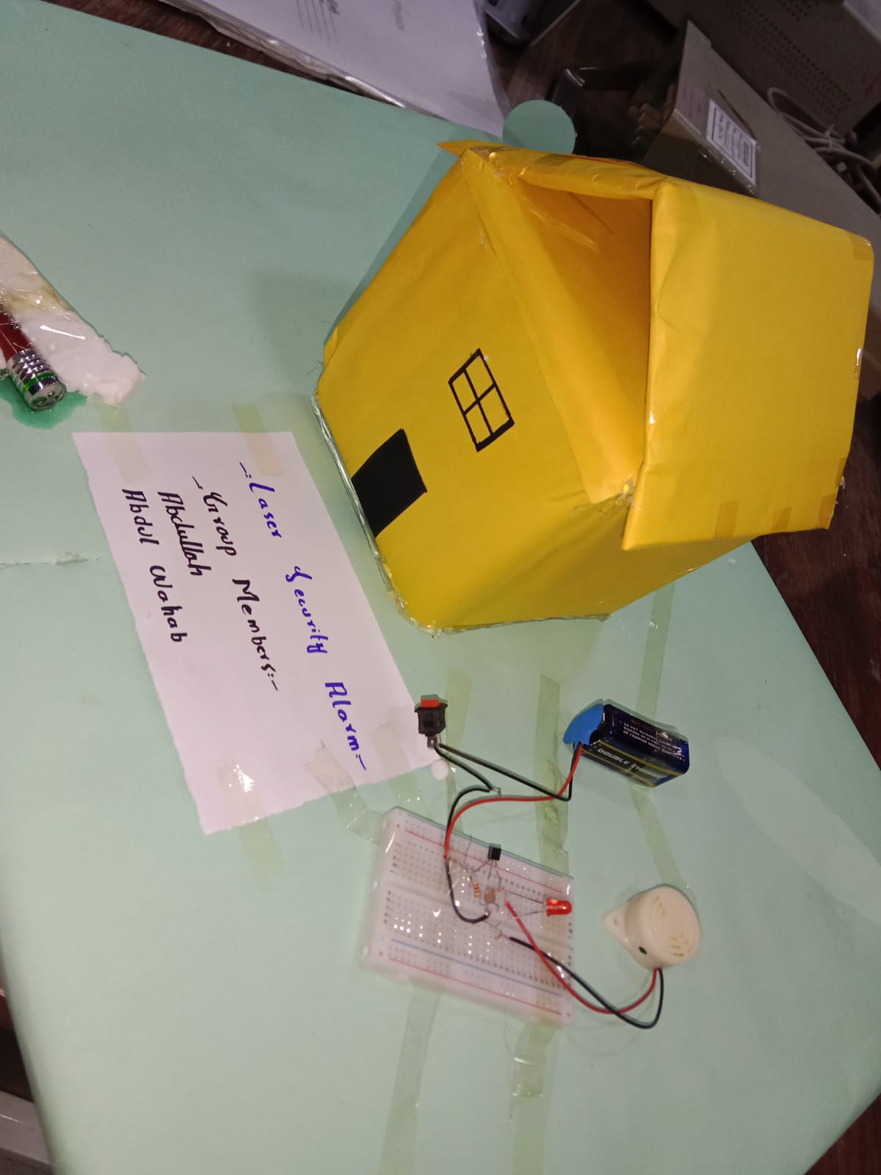

1. **Reference:**

* **YouTube Tutorial:**

<https://youtu.be/1EH_fxebXEU>

* **Research Paper:**

<https://www.academia.edu/42641050/A_PROJECT_REPORT_On_LASER_SECURITY_ALARM_SYSTEM>